The Number of Active Beehives in Correlation with Land Use/ Land Cover in Humboldt County

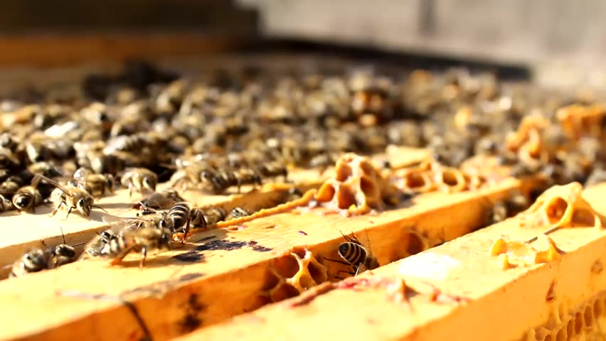

Ashli Gonzales- Griffin
Carlos D. Calleja

Abstract
European Honeybees (Apis mellifera) are recognized to be the most economically valuable pollinators of agricultural crops worldwide, and they strongly influence ecological relationships, ecosystem conservation and stability, and genetic variation in the plant community (Hammond and Blankenship, 2009). This study located undisclosed apiaries, a collection of beehives, which were marked by using a handheld Global Positioning System (GPS) in areas around the cities of Arcata and Eureka. We then proceeded to count the number of active hives at each site, and conducted our analysis based on the relationship of each apiary and their surrounding land use/land cover area.

Introduction
Pollination is one of the most important natural processes that often go unrecognized. For many years honeybees have been in decline, yet have worked with flowering plants over the course of 80 million years and are responsible for more pollination than any other animal. These hard-working invertebrates help pollinate over 75% of our flowering plants, and nearly 75% of our crops (Raven, et. al. 2005). Of the 57 most important monoculture crops, bees take care of 39 that includes: blueberries, squash, oranges, almonds, and not to mention coffee and chocolate (Geoffrey, 2010).
For our project we collected apiary locations through the help of Humboldt County’s Beekeepers Association, and at each given location we counted the number of active hives. These undisclosed apiary locations were marked by using GPS waypoints in areas around the cities of Arcata and Eureka, and through the use of acquired land use/land cover data we analyzed their locations and correlated that with the amount of active hives at each site. The participants have asked us to not disclose their personal information, therefore our second part of analysis will consist of how to run and accumulate data in a quantitative and confidential approach through the use of an Institutional Review Board (IRB) certification held by Ashli Gonzales-Griffin.
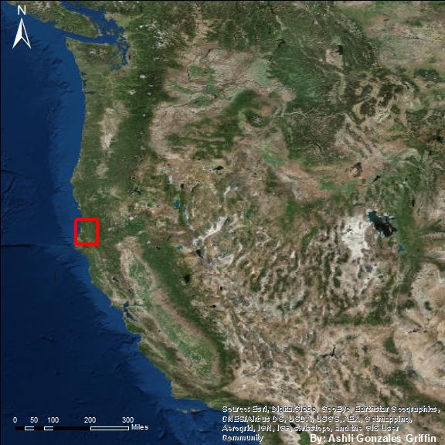
Figure 1 Locator Map of Humboldt County

Methods
Apiary locations were collected with the use of a Garmin Oregon 450t, handheld Global Positioning System (GPS) that was borrowed from the Forestry Stockroom at Humboldt State University (HSU). To protect the human subjects that were involved during this study, group member Ashli Gonzales-Griffin completed an application to the Institution Review Board (IRB).
On behalf of members who participated from the Humboldt Beekeeping Society, addresses were accumulated by emails in a private yahoo group forum for strictly beekeepers. A total of twenty-one addresses were given, with a total of 24 interested participants. The remaining three never got back to us with their information. Once addresses were collected we drove to each location and marked them as a waypoint. After all data points were collected, we then imported the GPS coordinates from an excel file to ArcMap by displaying X & Y data based on latitude and longitude. To make the data more accessible we then exported the points and created a shapefile that has all the address information attached in the open attributes table.

We then proceeded to acquire the Land Use Land Cover (LULC) map layer from the United States Department of Agriculture (USDA) Geospatial Data Gateway website for Humboldt County, California. Once the data file was downloaded we displayed it onto ArcMap 10.2 software, and proceeded to reclassify the land cover into seven classifications by using the “Reclassify” tool:
- Open Water
- Wetlands
- Shrubs
- Hay/ Pasture
- Developed
- Forest
- Barren land
These classifications enabled us to determine in what type of land use/land cover the apiaries were surrounded by (Figures 2 & 3). We then analyzed the locations by “Ground Truthing” in order to better interpret the area of each site, which is described in Table 1 (below). Being that our study was conducted in a confidential approach, the location of each site were undisclosed and were identified as “Identification Points” and not the addresses.

Results
What was discovered during this study is that if a beekeeper is surrounded by the habitat and pollination needs a colony requires, the higher the hive count will be. Since the degradation of pollinator habitat is one of the biggest reasons why population numbers are increasingly becoming lower, we decided to analyze the number of active beehives in correlation with land use. If the land use provides sufficient pollination syndromes then it is considered a suitable habitat for honeybees. For example, honeybees are attracted to the color, smell and the pedals landing platforms. In particular they enjoy smells that are rich in fruit and flower scents similar to perfumes. Bees also have great ultra violet vision that attracts to color pigments of blue, indigos and yellows. These are the pollination syndromes that are essential when choosing during cross-pollination.
We have two different maps, Figure 2 solely our eyes and Figure 3 to share with the participants from Humboldt County Beekeepers Association. Our table represents each point identification with its number of hives and land use correlation. The analysis performed was to pinpoint where the most and least suitable habitat can be located for pollinators.
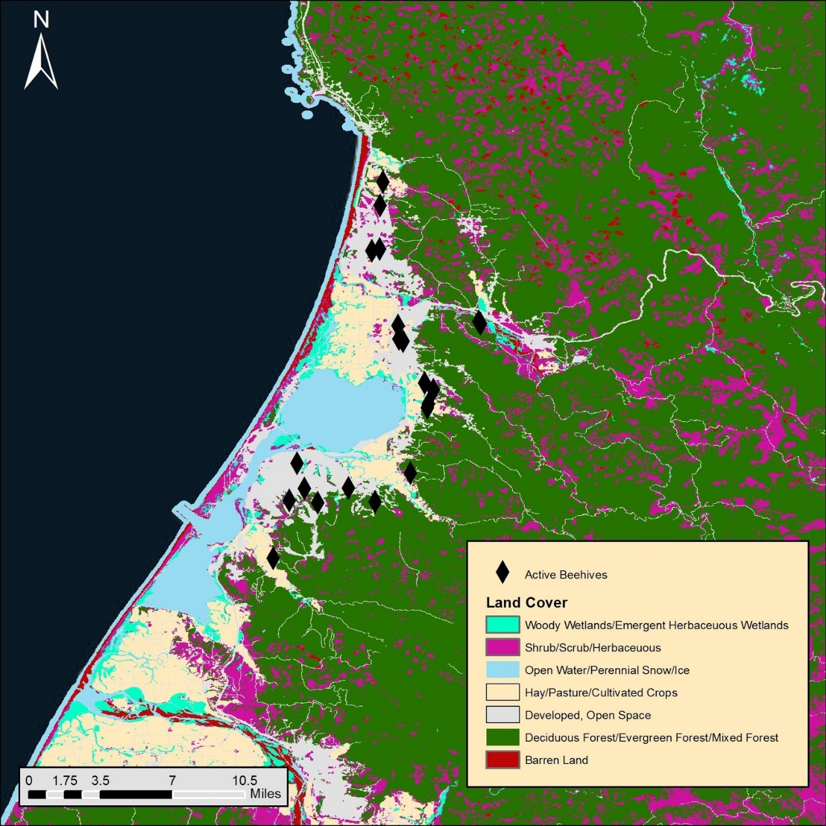
Figure 2 Individual apiary locations within Humboldt County. Confidential Apiary locations.
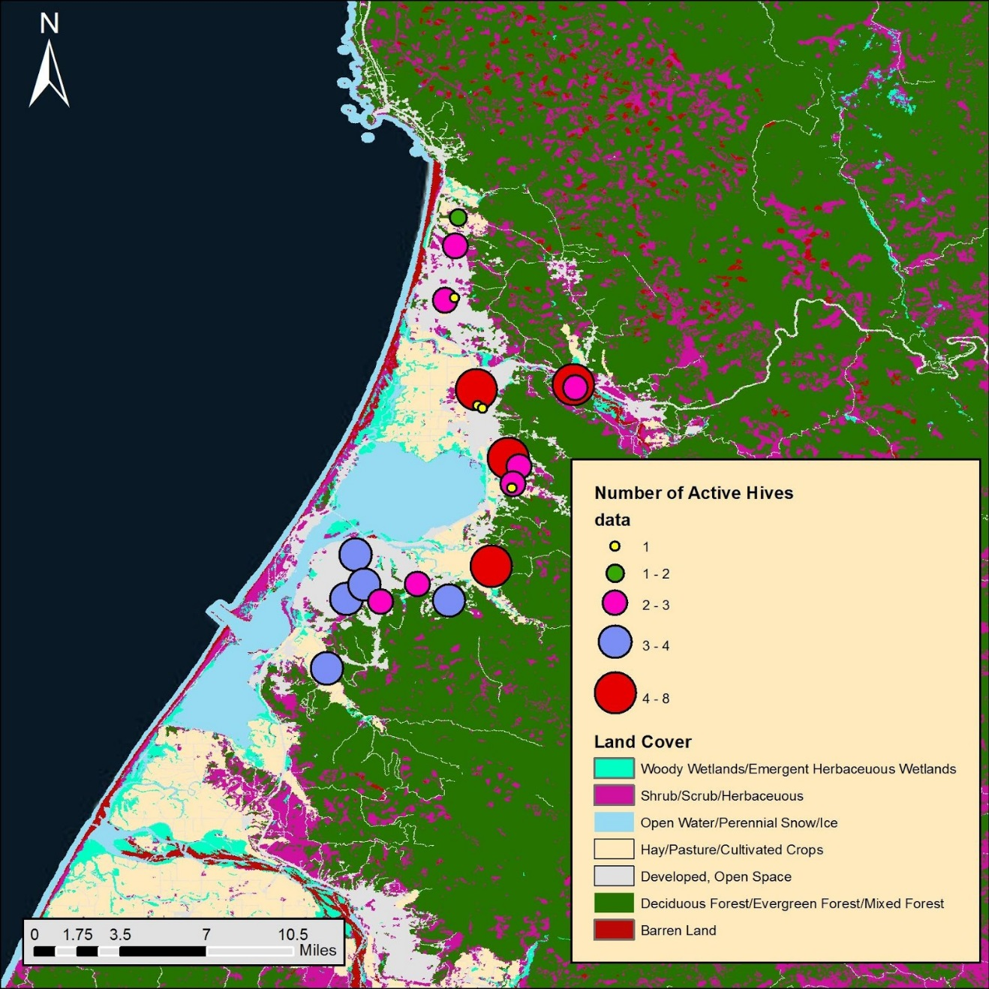
Figure 3 Apiary and LULC public map

Point Identification | Number of Hives | LULC | Ground Truthing
A05 | 2 | Developed, Open Space | Agricultural fields, Housing
A06 | 3 | Developed, Open Space | Near Arcata airport
A07 | 1 | Developed, Open Space | Near highly developed residential neighborhood
A03 | 3 | Developed, Open Space | Residential community  334 meters away from Open Space
J14 | 8 | Hay/Pasture/Cultivated Crops | Agriculture fields near large open space
U12 | 1 | Developed, Open Space | Residential neighborhood  Residential neighborhood
R13 | 1 | Developed, Open Space | Residential neighborhood
U09 | 8 | Shrub/Scrub/Herbaceous | Farmland near forestry areas
Y08 | 3 | Shrub/Scrub/Herbaceous | Farmland near forestry areas
A10 | 7 | Hay/Pasture/Cultivated Crops | Agricultural field, Open space
A04 | 3 | Developed, Open Space | Housing developments nearby forest and open space.
A11 | 3 | Hay/Pasture/Cultivated Crops | Large open green field, some housing developments.
A15 | 1 | Hay/Pasture/Cultivated Crops | Large open green field, some housing developments.
A24 | 7 | Shrub/Scrub/Herbaceous | Open fields with forest access.
A23 | 4 | Developed, Open Space | Completely surrounded by forest and small open fields.
A22 | 3 | Developed, Open Space | Living on edge of open green space near some housing development.
A21 | 3 | Developed, Open Space | Some housing development, brim of a large amount of access to green open space.
A20 | 4 | Developed, Open Space | 241 meters away from green open space
A16 | 4 | Developed, Open Space | Furthest participant away from 1,257 meters of green open space. Lots of housing development.
A19 | 4 | Developed, Open Space | Housing development, near large amount of open space/forest.
U17 | 4 | Hay/Pasture/Cultivated Crops | Agriculture, some housing development
Table 1 Summary of apiary locations and LULC
Yellow low density
Green Moderate
Purple High-Moderate
Red High

Conclusion
In conclusion the data collected was sufficient enough information to perform such comparisons of land use/land cover codes to apiary locations. We were able to successfully gather data using a handheld GPS and downloadable shapefiles for land use/land cover codes. The point locations surrounded areas where food production, open space and forested regions were. This is just what we anticipated as pollinator populations do much better in areas that meet their habitat criteria. What would make this study better is having more Humboldt County Beekeepers participate to really be sure successful hives occur around pollinator habitat. Maybe there could be an outlier that challenges the majority but we would not know until there were more hive locations to plot. As a result of creating Figure 3 we were able to share our confidential map at the May 2016 BeeFest that Humboldt County Beekeepers Association held at Bayside Grange. Here we were able to collect a few more interested participants, so this study will continue to grow so long as there are willing participators.

Acknowledgements
We would like to thank Buddhika Madurapperuma for helping us develop the skills it takes to perform such analysis. Also, Jim Graham for further skill development during lectures throughout the spring 2016 GIS course. Last but not least the Humboldt County Beekeepers Association for being willing to share private information on behalf of best management practices for pollinators.

References
Congressional Research Service Report. 2015. Bee Health: Background and Issues for Congress.
Hammond, G. and M. Blankenship. 2009. Apis mellifera. Animal Diversity Web. Accessed April 20, 2016 at http://animaldiversity.org/accounts/Apis_mellifera/
Raven, Peter H., Evert Ray F., and Eichhorn Susan E. Biology of Plants. New York: W.H. Freeman and Company Publishers, 2005. Print.
Williams, Geoffrey R., et al. “Colony Collapse Disorder in Context.” Bioessays 32.10 (2010): 845-846 Academic Search Premier. Web. 7 Nov. 2013.

